**APPLICATION CONTAINERIZATION**

**LAB EXPERIMENT 5**

**SUBMITTED BY:**

NITISH KUMAR SINGLA

500071913

R171218126

**SUBMITTED TO:**

HITESH KUMAR SHARMA SIR

**Docker Link**

Run a container in detached mode with name "db" from image "training/postgres"

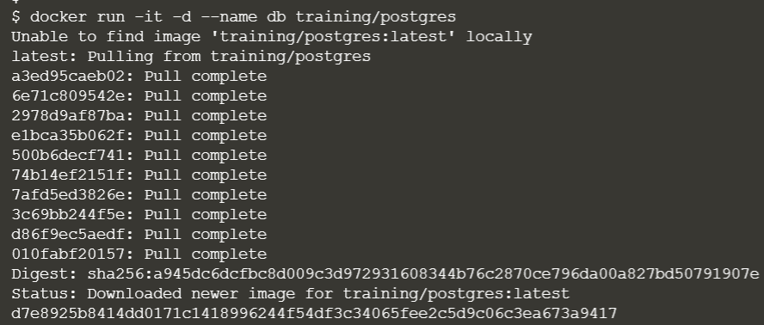



Run another container in detached mode with name "web" from image "training/webapp", link container "db" with alias "mydb" to this container and finally pass an inline command "python app.py" while running container.

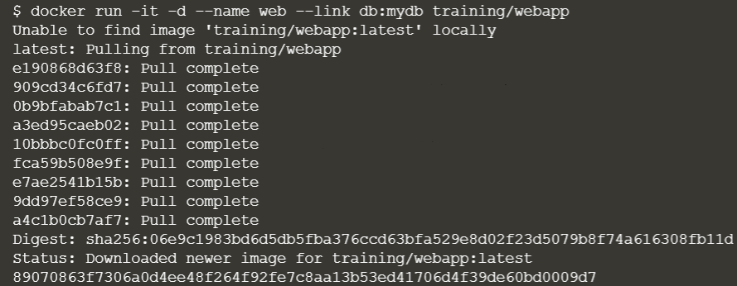



Take a bash terminal in "web" container and Test container linking by doing a ping to "mydb"

